Department of English

421 Denney Hall
164 Annie & John Glenn Ave.
Columbus, OH 43210

614-292-6065 Phone
614-292-7816 Fax
english.osu.edu

March 3, 2023

Dear Vice Provost Smith,

The English Department would like to eliminate one of the minors currently housed within our department, the Critical & Cultural Theory Minor. Originally designed in 2013 to emphasize both literary, critical, narrative, and cultural theory to undergraduate students in the humanities and social sciences, the minor has not been popular since its inception. Since 2014, only 3 students have ever successfully completed it, and we currently have 1 student enrolled who is graduating at the end of this semester (Spring 2023). As such, we would like to implement the removal at the beginning of Summer 2023 or before Fall 2023 if possible.

On behalf of the Department of English, thank you for your consideration.

Sincerely yours,

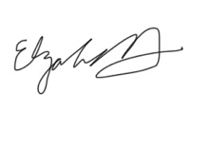
Elizabeth Hewitt

